**Assignment 11**

**Task 1.** **Open the Excel file in the above folder and create a basic table showing data for sales of houses in different areas:**

Step 1. After loading the data, click on Transform Data for completing cleaning steps.

Removed blank rows,rows with errors, rows containing #NA, promoted headers as first rows , changed Column Handover Date to Date type

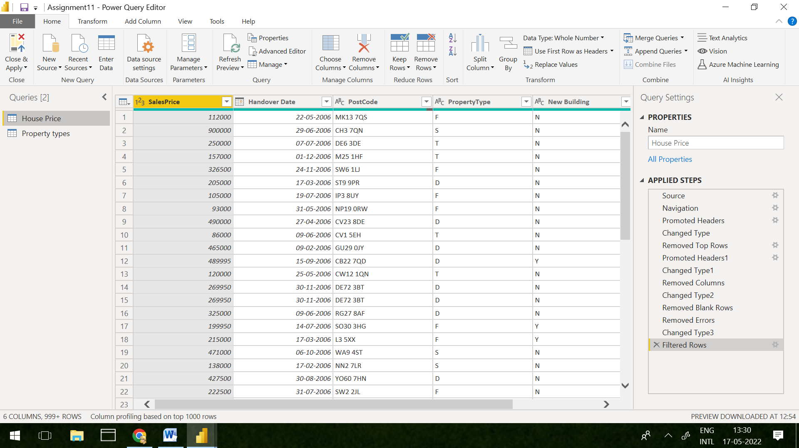

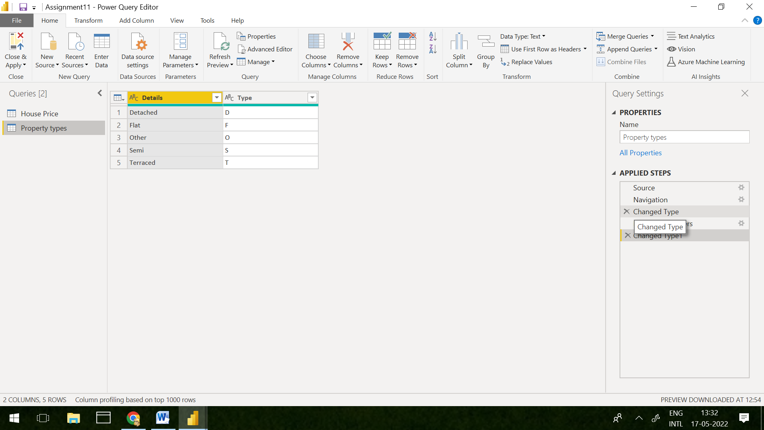

Step 2. In model view, establish relationship between property type in House Price and Type in Property Types.

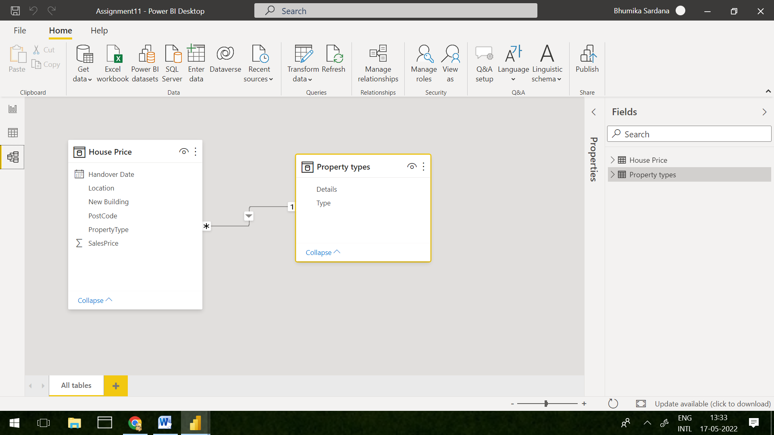

**Task 2. There are two options available: create 5 independent reports or use the one report but filter it to show data only for the current user. The later can be performed using roles:**

Step 3. In Modeling section, by clicking on manage roles and create roles as below

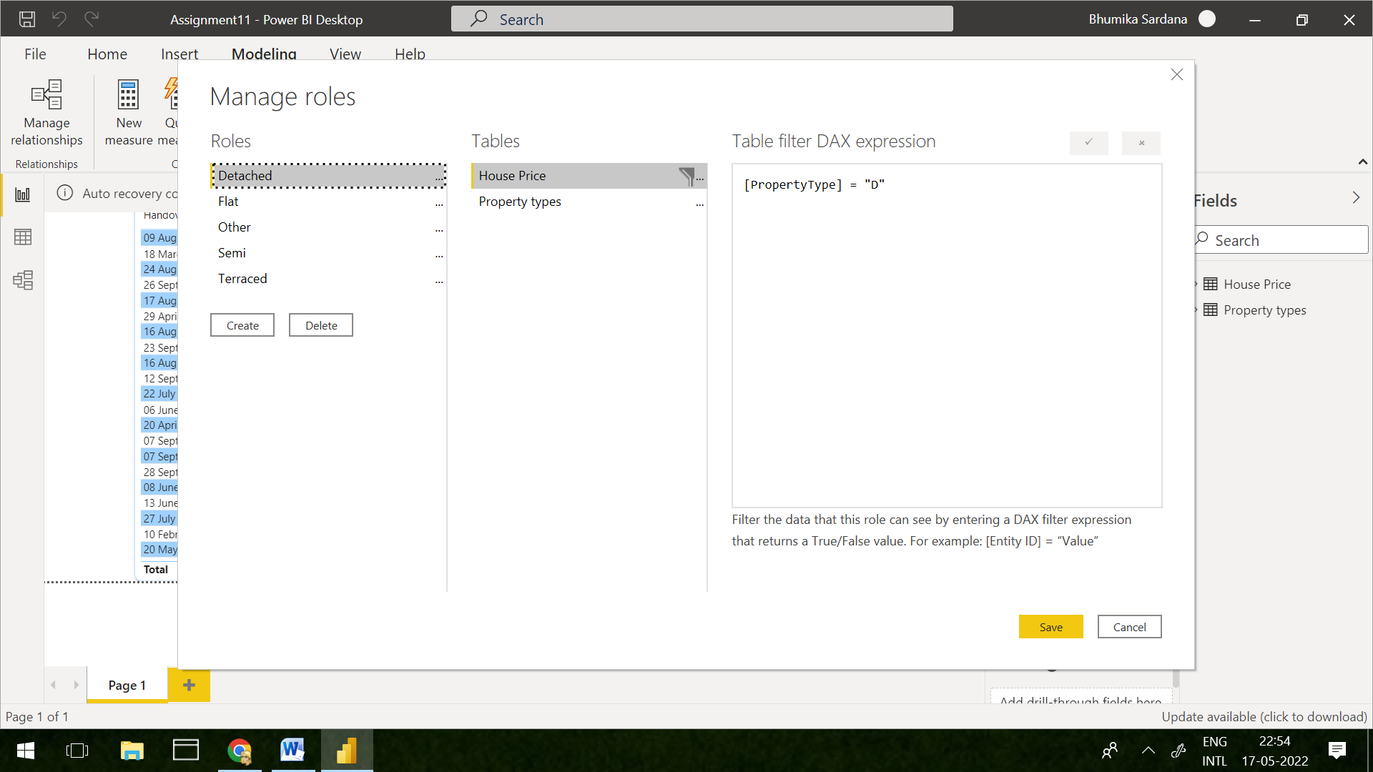

Step 4. Again in Modeling section, you can test roles

Expected Output

